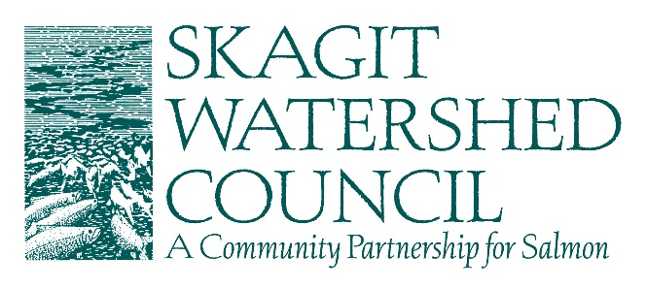

Draft Agenda
Lead Entity Citizen Committee (LECC) Prioritization Decision Meeting
August 11, 2022, 9:00am-11:00am, Hybrid Meeting

General Public can attend at SWC Office (815 Cleveland Ave), or
Join meeting by Zoom

Materials available in Box

9:00 | Beginning Business  - Introductions and agenda review (#1)  - Approve July 21st notes (#2)
9:10 | Meeting Process Review  - Review LECC role, decision making process, and ground rules (#3a and b)  - Review approved conflict of interest matrix (#4)  - Review LECC prioritization criteria (#5)
9:20 | Project Discussion in order if necessary (no changes were requested of sponsors)  - Milltown Island Construction  - 2022 Habitat Acquisition  - Alder Creek Riparian  - Barnaby Riparian  - Davis Slough Riparian  - 2022 Collaborative Riparian (set aside)  - Similk Estuary Final Design  - SFEG Riparian  - Clark Creek Design  - East Fork Nookachamps Design  - Bowman Bay Feasibility  - Cedar Grove cost increase
9:40 | Funding options  - Approve the color of money by project  - Provide input to SWC Board on funding set-asides for 2023 RFP
10:00 | Prioritize Projects  - Add any necessary project conditions;  - Add any recommendations to amend projects  - Approve motion(s) to rank, re-rank or remove projects;
10:40 | Approve SWC 2022 4 Year Work Plan and Planned Project Forecast List (#6)
11:00 | Adjourn

